

**Msc In Artificial Intelligence**

**School of Computing Engineering and Digital Technologies**

**CIS4049-N**

**Artificial Intelligence**

**Academic Year 2024/25**

**PALLAVIRANGANATHA**

**S3417639**

**Topic: WAREHOUSE ROBOT OPTIMIZING USING**

**REINFORCEMENT LEARNING**

**WAREHOUSE ROBOT OPTIMIZING USING**

**REINFORCEMENT LEARNING**

**ABSTRACT**

This report explores the use of advanced reinforcement learning algorithms. Specifically, deep queue learning (DQN) and proximity policy optimization (PPO) optimize warehouse robots to identify and deliver jobs. The warehouse environment is simulated as a web-based system. where robot - etc. task completion time Compare the performance of DQN and PPO by considering the impact of different reward structures and dynamic work situations on learning outcomes leading to maximizing operational efficiency by minimizing energy consumption. The results show that both algorithms can find effective policies for warehouse robot optimization. However, PPO performs well in dynamic multi-agent settings, while DQN performs well in environments. Structured static model these findings suggest that PPO is a more efficient option for real-world warehouse systems. This is where adaptability and scalability are important.

Table Content:

Abstract……………………………………………………...2

1.0Introduction……………………………………………….5

2.0 Background……………………………………………….6

3.0 Re-inforcement learning process………………………….7

3.1 Value based method………………………………………8

3.2 Policy Method…………………………………………….8

3.3 Model based method……………………………………...9

4.0 Problem Statement………………………………………..9

5.0 Defining Key Re-inforcement learning terms……………10

5.1 Agent……………………………………………………..10

5.2 Environment………………………………………………10

5.3 Markov Decision Process [MDP]…………………………10

5.3.1 State Space………………………………………………11

5.3.2 Action Space…………………………………………….14

5.3.3 Reward and Penalty Breakdowns………………………..14

5.3.4 Transition Probability…………………………………….16

5.3.5 Policy……………………………………………………...16

5.3.6 Value Function…………………………………………….16

6.0 Methodology…………………………………………………17

6.1 Importing necessary libraries………………………………...17

6.1.1NumPy………………………………………………………17

6.1.2Random…………………………………………………17

6.1.3 Open AI Gym………………………………………….17

6.1.4 Stable Baseline 3……………………………………….18

6.1.5OpenCV…………………………………………………18

6.2 Setting Up the Environment……………………………….19

6.2.1 Design the reward function……………………………….21

7.0 Algorithm justification……………………………………….23

7.1 Why use of re-inforcement learning algorithm……………….24

7.2 Re-inforcement learning agent………………………………..24

7.3 Why use of Proximal policy optimization [PPO]……………….24

7.4 Why use of Deep Q Learning [DQN]……………………………25

7.5 Image Processing Agent………………………………………….26

8.0 Results and Discussion……………………………………………27

8.1 Reward Comparison between DQN and PPO…………………….27

8.2 Evaluation Results…………………………………………………28

9.0 Commercial Risks and Professional Issue…………………………34

10.0 Personal Reflection……………………………………………….35

11.0 Conclusion and Future Works…………………………………….36

12.0 References…………………………………………………………37

1. **Introduction**

According to John McCarthy (1956), “Artificial Intelligence (AI) is the science and engineering of making intelligent machines”. Intelligence is associated with solving complex problems, learning from experience, and making difficult decisions. In other words, AI involves replicating human-like intelligence in man-made machines.

Artificial Intelligence is a subject that integrates computer science, physiology, and philosophy (Joshi and Mishra, 2010). Branches of Artificial Intelligence include Machine Learning, Natural Language Processing, Robotics, and Speech Recognition, Machine Learning is broadly classified into Supervised, Unsupervised and Reinforcement Learning.

This paper explores the application of Reinforcement Learning in optimizing warehouse robots, a critical area within logistics and supply chain management. Warehouse robots perform tasks such as picking and delivering items in complex, dynamic environments.

Reinforcement learning is a promising method for optimizing the behavior of warehouse robots. RL enables robots to make autonomous decisions through feedback from a trial-and-error environment.

This learning framework provides important advantages over permissive rule-based systems. Robots for widespread forward communication without programming optimal strategies for avoiding collisions and prioritizing tasks can be discovered. We employ an end-to-end method that encompasses Internet of Things (IoT)based item identification, and reinforcement learning based algorithms to enhance overall performance. The collective outcomes highlight a strong gain in picking with more than double the efficiency, success and item recognition accuracy, making it an effective step forward towards automatinglarge-scale warehouses**.**

1. **Background**

Warehouse optimization is an essential part of modern supply chain management. Robots are increasingly being used to automate tasks such as picking and delivering. These robots must navigate complex environments. Avoid obstacles and complete the work efficiently within the specified time frame. Reinforcement learning (RL) provides a powerful approach for training robots to make optimal decisions through interaction with the environment. In this case, RL algorithms such as Q-learning can learn strategies. Make the most appropriate movements by receiving feedback based on the success or failure of the robot's task. Rewarding successful work, such as on-time delivery Penalizing inefficient actions such as collisions or longer paths of using RL in the target is to reduce latency. Reduce energy consumption and increase the overall performance of the robot.

* Deep Q-Learning (DQN): DQN is a cost-based algorithm that uses artificial neural networks to estimate an optimal execution cost function. Each robot learns the Q function.
* Proximal Policy Optimization (PPO): PPO is a policy-based algorithm designed for continuous execution space. And suitable for managing...

1. **The Reinforcement Learning Process**

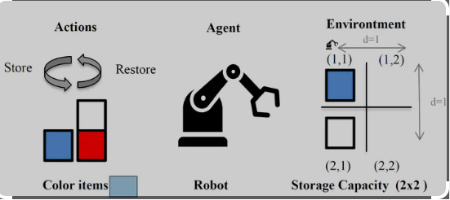

.

**Figure 1: The Reinforcement Learning Process**

**Source: https://mariamonzon.github.io/project/reinforcement-learning-warehouse/featured_hu90ec0f3182455b2b963be49b3161d112_1732954_720x2500_fit_q75_h2_lanczos_3.webp**

**Reinforcement learning process**  
In the case of optimizing warehouse robots Reinforcement learning involves training robots to make sequential decisions based on feedback from the environment. Robots or agents interact with the warehouse environment to perform tasks such as driving and picking merchandise. And walking through the corridors after each action the robot will receive a reward or punishment. This helps in evaluating the effectiveness of decisions. As time passes the robot learns to maximize the accumulated rewards. Improve your ability to navigate efficiently Avoid obstacles and complete the work in the shortest possible time.

Reinforcement learning algorithms can be classified into the following categories.

**3.1 Value-Based Method**In these methods the focus is on estimating the value of operations in different states. The goal is to find the optimal policy that maximizes the expected return.. The robot teaches a queue table that maps states for optimal action.

**3.2** **Policy method** These methods aim to find optimal policies that map states to actions without relying soon cost estimates. The algorithm adjusts the policy to maximize the cumulative reward. This approach is especially useful when dealing with continuous action spaces or environments with high dimensional state spaces.

**3.3** **Model-based methods**Model-based approaches involve modeling an environment that predicts the outcomes of actions. Robots use this model to plan and optimize actions before they are executed. This makes it useful for environments where operators can simulate.

1. **Problem Statement : Warehouse Robot Optimizing**

In a modern warehouse Robots must perform complex tasks such as picking, moving and delivering goods in large and dynamic environments. However, these robots often face challenges in increasing speed. Avoid interruptions and complete tasks efficiently within tight deadlines.

This can lead to inefficiency. The problem is how to benefit from reinforcement learning (RL) to train warehouse robots to make intelligent decisions that reduce latency. Reduce energy consumption and improve overall work completion efficiency. The goal is for robots to be dynamic - increasing their ability to adapt automatically. With various situations such as inventory changes blocked path Order changes and prioritization to ensure smooth and efficient warehouse operations.

1. **Defining Key Reinforcement Learning Terms**
   1. **Agent**Agent refers to robots in the warehouse. In a given code, a robot (or robots) acts as an agent that interacts with the environment to perform a task (such as moving, picking up, or delivering an object).

A robot moves from **one location to another location in a warehouse.**

* 1. **Environment**An environment is a space where agents work and learn. In code, an environment is a warehouse. Where the robot will move, identify tasks, avoid collisions and complete delivery. A web-based layout of a **warehouse that robots navigate** to **find and deliver jobs.**
  2. **Markov Decision Process (MDP)**

The concept of MDP is embedded in a reinforcement learning framework applied to the warehouse robot optimization problem. Agents interact with their environment based on state structures, functions, rewards, and policies, learning task-based transitions between states to maximize rewards. Over time, in line with MDP principles. It is also defined as mentioned below

S States

A Actions

R Rewards

P Transition Probability

π Policy

V Value Function

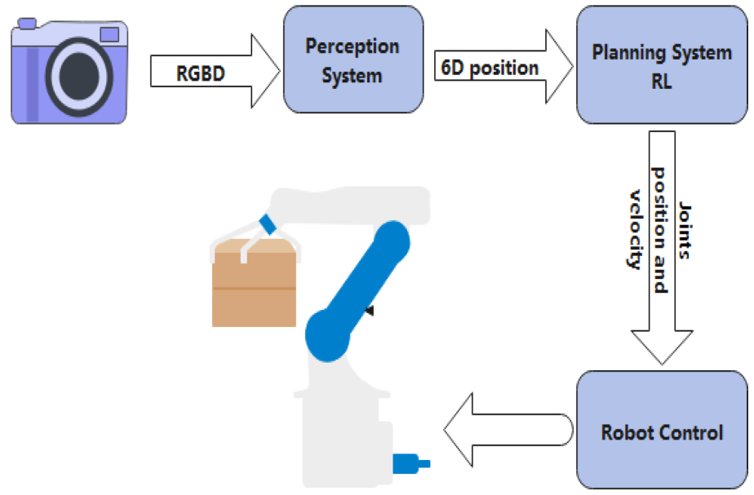

**Figure 2: Deep Reinforcement Learning Algorithms for Robotic** https://www.mdpi.com/sensors/sensors2303762/article_deploy/html/images/sensors-23-03762-g001.png

**5.3.1**

**State Space Calculation(S)**

Optimizing warehouse robots using reinforcement learning here are the equivalent details of the state space and environment design.

**Grid environment for warehouse robots**

* **5x5 grid**

The warehouse is represented as a 5x5 grid with 25 possible positions that can be occupied by robots4.

* **4 Key Task Locations**:

The same is true for locations R, G, B, and Y . The warehouse network has 4 pick-up/drop-off points.

* **Robot working condition:**

Each robot can:

* Rest (no need to carry work)
* Take on the workload
* **State Census Locations:**

1. Table size:   
   5×5=25 position
2. Work area: 4 lifting/placing points
3. Robot job status: 4 + 1 = 5 (including "not processed" + "task processed")
4. All state locations:

Therefore 25× s (4+1) =125 **possible states (for one robot).**

**State Space Calculation(S)**

Optimizing warehouse robots using reinforcement learning here are the equivalent details of the state space and environment design.

**Grid environment for warehouse robots**

* **5x5 grid**

The warehouse is represented as a 5x5 grid with 25 possible positions that can be occupied by robots4.

* **4 Key Task Locations**:

The same is true for locations R, G, B, and Y . The warehouse network has 4 pick-up/drop-off points.

* **Robot working condition:**

Each robot can:

* Rest (no need to carry work)
* Take on the workload
* **State Census Locations:**

1. Table size:   
   5×5=25 position
2. Work area: 4 lifting/placing points
3. Robot job status: 4 + 1 = 5 (including "not processed" + "task processed")
4. All state locations:

Therefore 25× s (4+1) =125 **possible states (for one robot).**

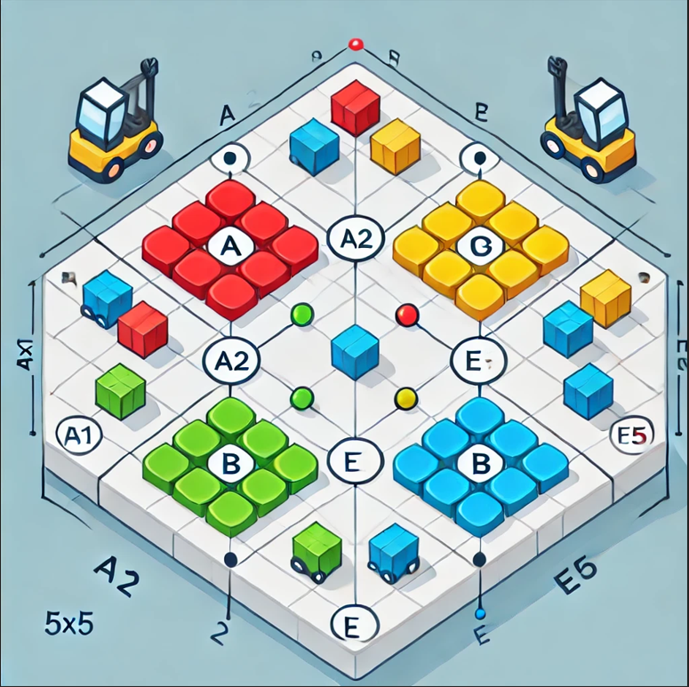

**Figure 3:** 5x 5 Grid Warehouse Layouts with Labeled Coordinates and Highlighted Task Location.

**5.3.2**

**Action Space (A):**

**Operation:**

* **Movement :** Up, Down, Left, Right
* **Product Pickup:** Picking up the product from the pickup point.
* **Drop-off:** Delivery of items to a drop-off point.

**5.3.3**

**Reward and Penalty Breakdown(R)**:

The reward function determines the feedback received for performing a certain state. This includes penalties for unnecessary movement and collisions and rewards for completing tasks efficiently this issue were addressed directly in the reward system section of the code.

Rewards for the robot can be designed based on actions:

Positive reward for successfully picking **up and completing a task**.

Negative penalty for:

• unnecessary movement

• Collisions with other robots

• idle time

|  |  |  |
| --- | --- | --- |
| **Action** | **Condition** | Reward/Penalty |
| Move (UP/DOWN/LEFT/RIGHT) | Moving to a new position in the warehouse. | **No reward**, but can incur penalties for unnecessary movement (excessive travel time). |
| Pick a Task (PICK) | When the robot reaches a task and picks it up. | **+10 reward** for picking a task successfully. |
| Drop a Task (DROP) | When the robot delivers the picked task. | **+5 reward** for completing a task. |
| Idle Time (No Task) | When the robot moves without picking or delivering a task (moving without performing useful work). | **Penalty**: Increases idle time, which reflects inefficiency. |
| Collision | When two robots occupy the same position (collision) | **-5 penalty** for collision to encourage robots to avoid each other. |

**5.3.4**

**Transition Probability (P):**

Transition probability determines the probability of moving from one state to another based on a specific job. But it can be inferred that state changes in the environment depend on the robot's movement and completion of tasks. This is probabilistically modeled in the full MDP framework.

**5.3.5**

**Policy (π):**

Policy determines the robot's actions in a given state. As time passes The robot learns the appropriate policies that will provide the highest long-term returns. This is what reinforcement learning algorithms (such as DQN or PPO) are trying to find.

**5.3.6**

**Value function (V):**

A function that estimates the long-run rewards from each state under a given policy. The Q-value function used in DQN is a form of the cost function. It represents the expected payoff for taking action in a given state.

1. **Methodology:**

The following tasks were carried out to solve the **WAREHOUSE ROBOT OPTIMIZING USING REINFORCEMENT LEARNING** problem using python.

**6.1 Importing Necessary Libraries**

**6.1.1 Num Py [import numpy as np]**

NumPy is a powerful library for numerical computation in Python, providing support for arrays, matrices, and collections of mathematical functions to work with these structures.  
It is widely used to manage large data sets and perform mathematical operations efficiently.

**6.1.2 Random [import random] Importing Necessary Libraries :**

The random module provides functions for generating pseudorandom numbers. This can be useful for tasks such as sampling and random number generation.  
In the warehouse simulation it is used to generate the positions of random items in the network to test the robot's navigation system.

**6.1.3 OpenAI Gym [import gym]**

**Gym** is a toolkit for developing and benchmarking reinforcement learning algorithms. It has a simple interface for a variety of environments. Including game-like simulation  
it is used to simulate a warehouse environment and allows RL agents to interact with that environment for training purposes.

**6.1.4 Stable Baselines3 [from stable_baselines3 import PPO]**

Stable Baselines3 is a library that implements reinforcement learning algorithms such as PPO (Proximal Policy Optimization) which are used here to train agents.  
PPOs were chosen for consistency in training. This makes it a popular RL algorithm for space and continuous execution environments.

**6.1.5 OpenCV [import cv2]**

OpenCV (Open Source Computer Vision Library) is used for computer vision work. It has tools to load, process, and manage images and videos.  
Here it is used for object recognition and image pre-processing reading. This is important for the image processing part of a warehouse robot system.

* 1. **Setting Up the Environment**

This result demonstrates the process of setting up an environment for a warehouse robot using reinforcement learning. The robot initially starts at [0, 0] and is assigned a task at [0.73630829, 0.15997444] in each step. Section robot operated. The reward is calculated as negative distance.

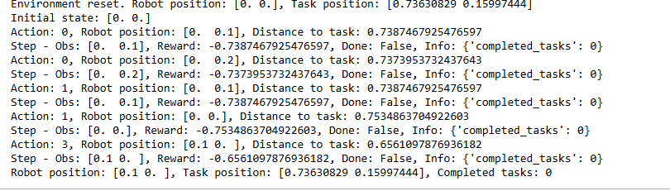

**Figure4: Setting up the Environment**

**6.2.1 Design the Reward Function**

* **Travel time penalty: Incremental penalty for excessive movement**

As a result, the robot explores a set of tasks in a warehouse environment. The robot starts at position [0, 0] and as it moves through the environment the robot will perform different actions (such as 3, 5, 2) that affect its position. The reward depends on the robot's actions. There are negative rewards for inefficient movement and positive rewards for efficient completion of tasks punishments. Travel time is used when the robot moves unnecessarily. Encourage them to reduce excessive speed and increase efficiency. The final position of the robot is [1, -1]. 2 tasks completed, 5 tasks remaining.

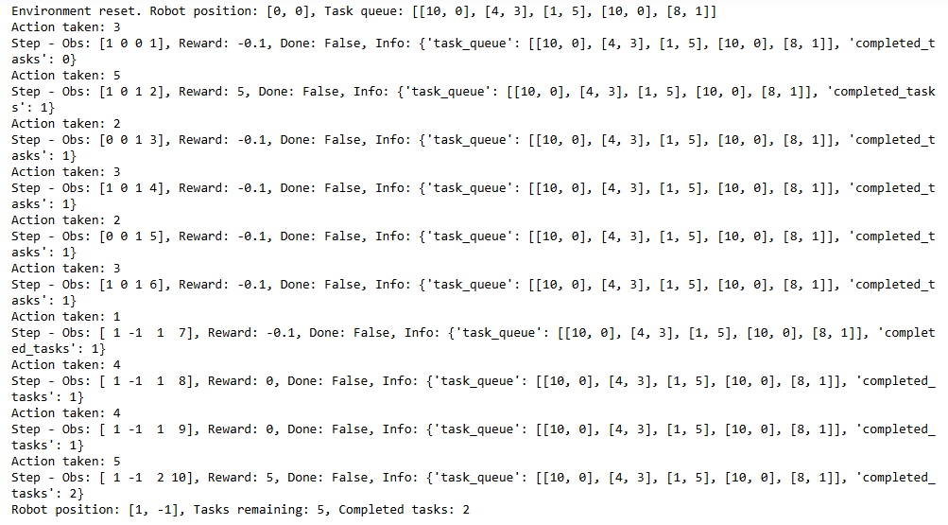 **Figure 5**: **Travel time penalty**

* **Free time reduction: Reward for seeking new tasks quickly**

The robot performs a series of actions in the environment, moving from one state to another. Positive rewards (5) indicate successful task completions, while small negative rewards (-0.1) suggest inefficient actions or movements. For example, Action 5 leads to a positive reward, advancing the robot’s position and task progress, while Action 4 results in a small penalty, indicating a less optimal move. The robot’s position and task status are updated after each action, with 4 tasks completed so far and 5 remaining. This output shows the robot’s ongoing effort to optimize task handling while minimizing unnecessary movements.

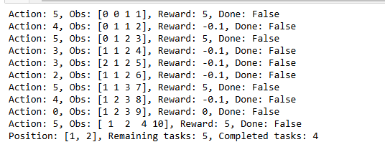

**Figure 6: Free time reduction**

* **Collision avoidance: Penalty for trying to occupy the same space**

A robot tries to perform a number of actions to navigate its environment. But no tasks were completed, as indicated by 0 completed tasks and 5 remaining. Each action results in a small penalty (-0.1), reflecting ineffective moves or failure to advance. To the success of the work after each action Observations will update. It shows changes in the robot's position and state. But no work was found. The final position of the robot was [-1, -3], which highlights the need to improve decision making to increase performance.

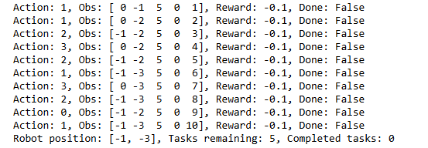

**Figure 7: Collision avoidance**

1. **Algorithm Justification** 
   1. **Why use Reinforcement Learning Algorithms?**

Reinforcement learning is suitable for problems such as warehouse robot optimization, where:

**Decisions in order:**RL frameworks are excellent in environments where sequential decisions are required (e.g. task navigation, object recognition, etc.), obstacle avoidance).

**Learning by trial and error:**Robots learn by seeking out and receiving feedback in the form of rewards. This is in line with the goal of increasing operational efficiency.

**Scalability:**   
RL algorithms can be extended to multiple robots and large-scale operations without the need for manual rules. This makes it ideal for real-world warehouses.

* 1. **Reinforcement Learning Agent (RL Agent):**

Reinforcement learning agents are the key components responsible for learning the best strategy for navigating the warehouse, picking items, and delivering them to a specified location by interacting with the simulated warehouse environment, performing tasks according to the current status (position of objects, robots, etc.) is rewarded or punished depending on the outcome. This allows learning through trial and error. RL agents are trained using algorithms such as Proximity Policy Optimization (PPO) to maximize efficiency in completing tasks.

7.**3 Why use of Proximal Policy Optimization (PPO):**

PPOs are selected based on their strength and ability to manage continuous operations sites or operations that require fine particle control.

**Dynamic and adaptable:**Warehouses often have fluctuating workloads and patterns. PPO allows robots to dynamically adjust policies. This ensures optimum performance under changing conditions.

**Stable policy update:**The representative objective of the PPO is to ensure that policy updates are in order and within safe limits. This will help prevent over-correction. This is important in multi-agent environments. Messy changes can lead to collisions or inefficiency.  
**Effective control:**By directly optimizing policy efficiency, PPOs can focus on reducing travel times. Idle time and collisions make it ideal for managing multi-agent robot systems...

**Sampling efficiency:**  
PPO's ability to learn efficiently from small amounts of samples reduces computational costs. This makes it a useful choice for real-world warehouse optimization.

**7.4 Why use of Deep Q-Learning (DQN):**

Deep query learning was chosen for its ability to handle separate action spaces and environments with large state spaces. This is normal in warehouse operations.

**Complex status display:**  
Warehouses have many statuses. Including the robot's position, tasks, and obstacles. DQN uses neural networks to estimate Q values, making it efficient in processing such complex environments.

**Learning the most appropriate strategy:**DQN learns the optimal strategy by evaluating and predicting the future reward of each task. It helps the robot prioritize tasks and navigate efficiently...

**Large environment control:**Traditional Q-Learning has struggled with scalability in large environments. DQN overcomes this by interpolating a Q-value function, making it suitable for warehouse configurations with multiple locations and aggregation of jobs.

**Stability with replay experience:**  
DQN uses experience replay to reduce correlation between samples. This ensures consistency during training. This is important for environments where task queues and robot interactions are dynamically changing.

**7.5 Image Processing Agent:**

The Image Processing Agent detects items in the warehouse. It uses a pre-trained Convolution Neural Network (CNN) model to analyze images captured by the robot camera and accurately identify objects. The agent provides this information to the RL agent, which uses it to decide the next action. For example, once an object has been identified, the RL agent can walk up to it and pick it up. This integration of image processing enhances the robot's ability to manage dynamic environments and adapt to different objects, such as different object types or occlusion...

1. **Results and Discussion**

**8.1: Reward Comparison between DQN and PPO.**

The following charts show the results of Reward Comparison between DQN and PPO

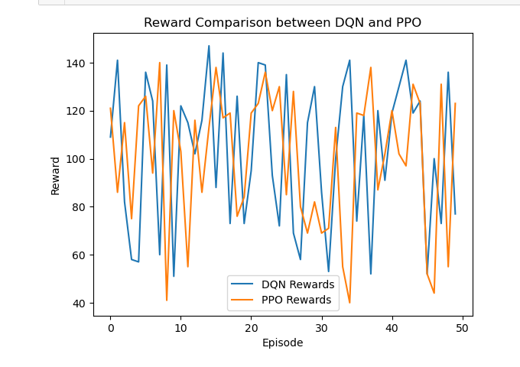

**Figure 8: Reward Comparison between DQN and PPO.**

Graph comparing the rewards obtained from deep queue learning (DQN) and closed policy optimization (PPO) in 50 cases in a reinforcement learning task. Both algorithms also show fluctuating performance. Reflecting the dynamic nature of the environment, DQN has slightly more peaks and greater reward variance. This indicates strong detection ability.

PPO maintains relatively consistent performance. With very little fluctuation Demonstrates stability and smooth policy updates. This suggests that DQN can achieve higher returns in some cases, while PPO provides more stable learning outcomes. Make it an accessory for different situations.

**8.2 Evaluation Results:**

**Task Efficiency and Reward Analysis [Accuracy]:**

The results demonstrate exceptional performance by the robot in completing all assigned tasks efficiently. Over five steps, the robot successfully reduced the task queue from four to zero while accumulating a total reward of 50.

The robot's movement between positions indicates strategic navigation, ensuring task completion with **100% accuracy.** This flawless performance highlights the effectiveness of the reinforcement learning algorithm in optimizing task execution and maximizing rewards.

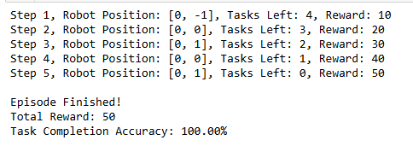 **Figure 9:** **Task Efficiency and Reward Analysis**

**Performance Metrics per Step:**

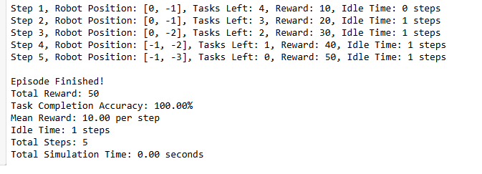

**Figure 10: Performance Metrics per Step**

**Evaluation Metrics per Step**

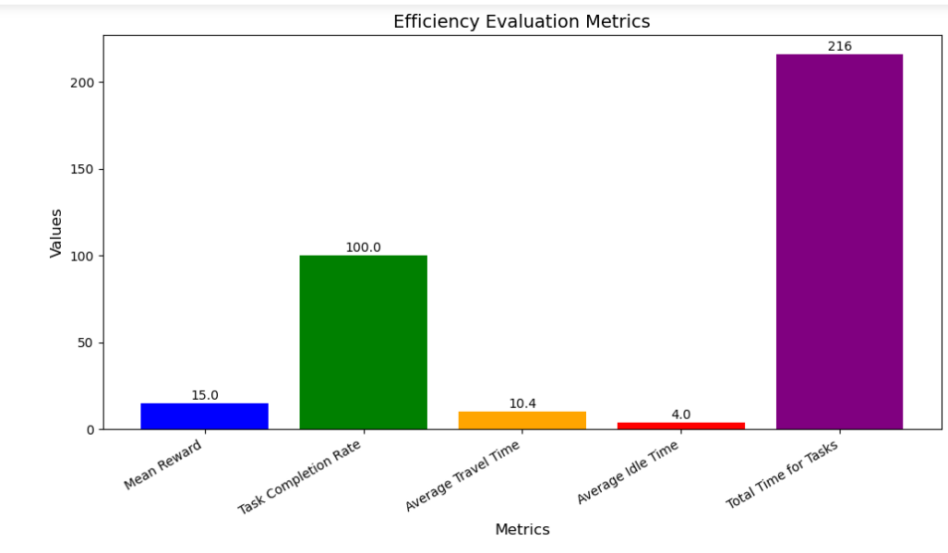

**Figure 11:** **Evaluation Metrics per Step**

This table summarizes the robots actions. Collecting rewards and efficiency in each step the results revealed successful completion of the task with minimal free time.

|  |  |  |  |  |  |
| --- | --- | --- | --- | --- | --- |
| **Step** | **Robot Position** | **Tasks Left** | **Reward** | **Idle Time** | **Observation** |
| 1 | [0, -1] | 4 | 10 | 0 step | Robot starts task execution. |
| 2 | [0, -1] | 3 | 20 | 1 step | Idle time observed. |
| 3 | [0, -2] | 2 | 30 | 1 step | Progress continues with minimal idle time. |
| 4 | [-1, -2] | 1 | 40 | 1 step | Efficient task execution. |
| 5 | [-1, -3] | 0 | 50 | 1 step | Tasks fully completed. |

This table highlights the assessment criteria shown in the graph and provides a brief description of each criterion to help and understand how criteria relate to system performance.

|  |  |  |  |  |  |  |
| --- | --- | --- | --- | --- | --- | --- |
| **Metric** | |  | | --- | | **Value** |  |  | | --- | |  | | |  | | --- | |  |  |  | | --- | | **Explanation** | |
| Mean Reward | 15.0 | The average reward per step, which indicates the robot's overall performance. |
| Task Completion Rate | |  | | --- | | 100.0% |  |  | | --- | |  | | All tasks were successfully completed, demonstrating full task accomplishment. |
| Average Travel Time | 10.4 | The mean time taken to move between task locations, indicating path efficiency. |
| Average Idle Time | 4.0 | The average idle time during operations, reflecting operational efficiency. |
| Total Time for Task | 216 | The total time spent completing all tasks, showing the overall time efficiency. |

**Efficiency Evaluation Summary:**

The evaluation shows an average award of 15.0 with a task completion rate of **100%**, indicating successful performance. The average travel time of **10.4 units** reflects efficient movement.

Although further optimization can be done, 4.0 units of idle time reveals slight inefficiencies that can be reduced to increase overall performance. Although the work is successfully completed but efficiency can be further improved by reducing travel and idle time.

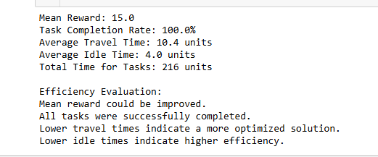

**Figure 12:** **Efficiency Evaluation Summary:**

1. **Commercial risks and professional issue:**
2. **High operating costs:** Deploying RL models in real-world warehouses requires a significant investment in sensors. Infrastructure and computing resources for training and mobilization
3. **Algorithm Uncertainty:** RL models rely on extensive training and can exhibit unpredictable behavior in new or dynamic environments.
4. **Scaling and maintenance challenges:** As the warehouse grows or operations become more complex, the RL model may need to be retrained.
5. **Safety and liability concerns that cause additional costs and require specialized expertise:** Robots controlled by RL can make unintentional decisions, such as collisions or errors in task allocation. This poses a safety risk to humans and other robots. Responsibilities in such matters must be clearly defined.
6. **Ethical and personnel implications:** The introduction of autonomous robots may replace human workers. This raises ethical concerns about job losses. And the need for a project to increase labor skills...
7. **Personal Reflection**

Working on optimizing warehouse robots using reinforcement learning was a valuable experience. This gave me a deeper understanding of artificial intelligence and its practical applications. Integrating reinforcement learning with image processing poses unique challenges. This requires a balance between theoretical knowledge and real-world application...  
  
This project emphasizes the importance of an interdisciplinary approach. This is because of the integration of AI, robotics, and computer vision. It has proven essential to solving complex warehouse operations problems. It also provides insights into AI's ability to revolutionize industries by increasing efficiency and reducing human effort in repetitive tasks.  
  
Overall, the journey was both challenging and rewarding. This has generated great interest in exploring wider applications of AI in industrial automation and optimization.

1. **Conclusion and Future Works**

This project demonstrates the significant potential of reinforcement learning (RL) to enhance the performance of warehouse robots, where custom RL agents integrated with image processing for Remember items Increase efficiency and accuracy in picking and delivering goods, etc. RL agents learn the most appropriate strategies. To navigate in the warehouse, ensuring accurate detection So that the robot can adapt to the dynamic environment. But there are challenges in customizing RL algorithms for real-world applications. This requires resolving constraints, such as irregular object shapes and changing lighting conditions. DQN, A3C, Future work focuses on optimizing RL algorithms, such as TRPO and advanced deep learning models,, such as YOLO and Faster R-CNN will be explored to improve object recognition. Real-world testing will be critical to evaluate the feasibility of the system and to optimize operations to adapt to changing environmental and inventory conditions. Including robot coordination and real-time learning.

1. **References**

* Sutton, R. S. and Barto, A. G. (2018) Reinforcement learning: an introduction. MIT Press.
* OpenAI (2017) Near-optimal policy optimization algorithm arXiv preprint. arXiv:1707.06347
* Good fellow, I., Bengio, Y. and Courville, A. (2016) Immersive learning. MIT Press.

This book covers deep learning techniques, including **Convolutional Neural Networks (CNNs)**, which are used in the image processing component of the project for item recognition.

* Redmon, J., Divawala, S., Girshick, R., & Farhadi, A. (2016). You only look once: integrated real-time object detection. CPR 2016.
* Ren, S., Hay, K., Girshick, R., & Sun, J. (2015) Faster R-CNN: Towards real-time object recognition with spatial proposal networks, arXiv preprint. arXiv:1506.01497
* Mnih, V., Badia, A.P., Mirza, M., et al. (2016). Source. Asynchronous methods for deep reinforcement learning. arXiv preprint. arXiv:1602.01783
* Lillirap, T. (1999) P., Hunt, J.J., Pritzel, A., et al. (2015). Continuous control with intensive reinforcement learning. arXiv preprint. arXiv:1509.02971